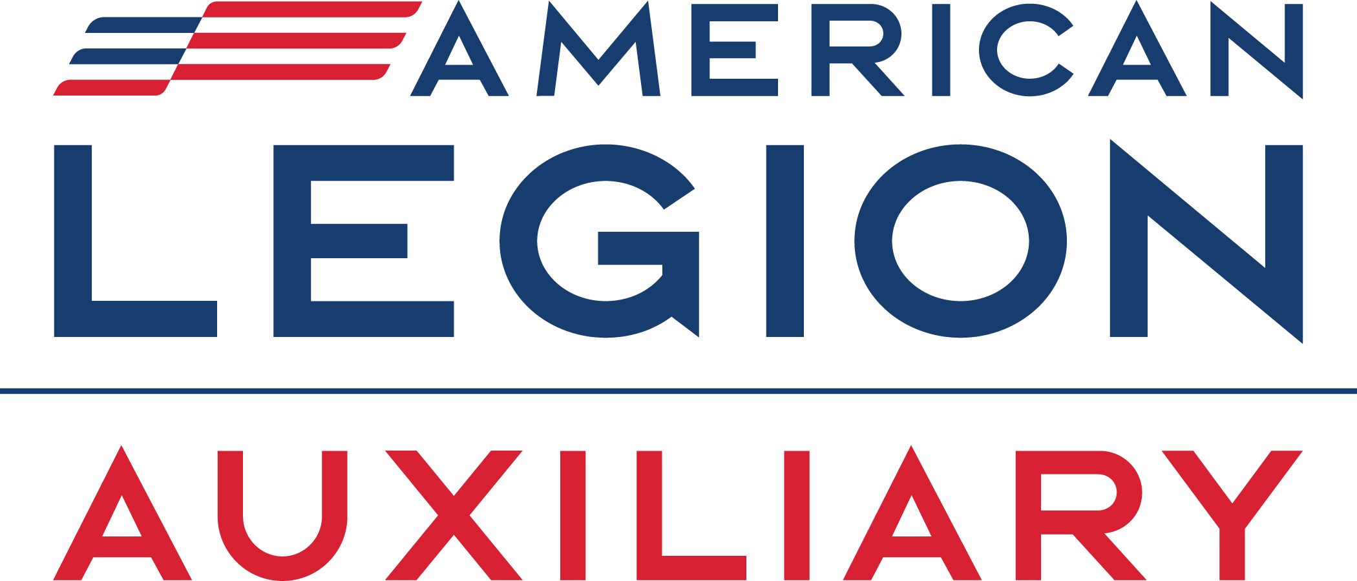

Media Release
DEPARTMENT OF STATE
Street Address, City, State ZIP Code
www.ALAforVeterans.org (and your unit’s website, if available)
Contact: [PR Chairman], [PR Chairman’s Phone Number]; [PR Chairman’s e-mail Address]
for [Department President’s Name]

[DATE]
FOR IMMEDIATE RELEASE

American Legion Auxiliary Unit [UNIT #] encourages [INSERT CITY NAME] to
honor fallen warriors on National Poppy Day®

[CITY]— Honor our fallen warriors and contribute to the continuing needs of our veterans on National Poppy Day®, May [FRIDAY BEFORE MEMORIAL DAY] from [INSERT TIME a.m./p.m.] at [LOCATION] when members of American Legion Auxiliary (ALA) Unit [INSERT UNIT #] distribute red poppies in exchange for a donation. The Flanders Fields poppy has become an internationally known and recognized symbol of the lives sacrificed in war and the hope that none died in vain. The American Legion Family called upon Congress to proclaim the Friday before Memorial Day as National Poppy Day, which was officially designated as such in 2017.

“Wearing the poppy on National Poppy Day and throughout Memorial Day weekend is one small way to honor and remember our fallen warriors who willingly served our nation and made the ultimate sacrifice for our freedom,” said ALA Unit [INSERT UNIT #] President [INSERT NAME]. “We must never forget.”

When The American Legion Family adopted the poppy as its memorial flower in the early 1920s, the blood-red icon became an enduring symbol of honor for the sacrifices of our veterans from the battlefields of France in World War I to today’s conflicts. The American Legion Auxiliary raises millions of dollars each year distributing poppies throughout the nation, with 100 percent of the funds raised going directly to help veterans, military, and their families.

For more information, call [preferably a number where media or interested persons can reach someone during day and evening hours].

The American Legion Auxiliary, founded in 1919, is a community of volunteers serving veterans, military, and their families. ALA members assist veterans in hospitals, advocate for veteran issues, support therapeutic creative arts festivals, distribute poppies for remembrance, and much more. In addition to serving the military community, the American Legion Auxiliary hosts ALA Girls Nation and the ALA Girls State programs that teach future leaders about government and civic responsibility. Learn more at www.ALAforVeterans.org and @ALAforVeterans on Instagram and Facebook.

###

