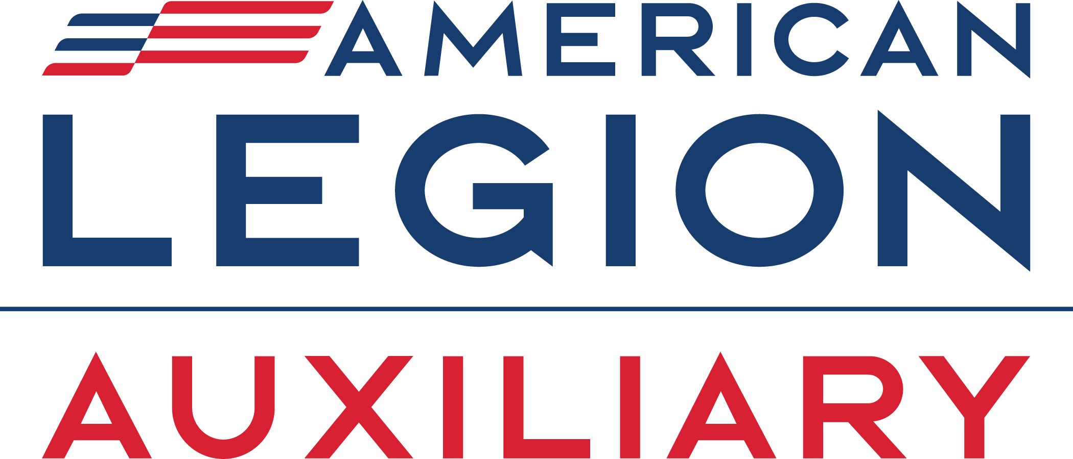

American Legion Auxiliary Department of [STATE]
Media Release
Street Address, City, State ZIP Code
www.ALAforVeterans.org (and your unit’s or ALA Girls State website, if available)
Contact: [PR Chairman], [PR Chairman’s Phone Number], [PR Chairman’s Email Address]

[DATE]
FOR IMMEDIATE RELEASE

Local Student Headed to American Legion Auxiliary Girls State

[CITY, STATE]- [Attendee's name] of [hometown] has been selected to attend American Legion Auxiliary (ALA) Girls State. The nonpartisan political program teaches students about local, county, and state government.

ALA Girls State attendees, known as “citizens,” receive special instruction in parliamentary procedure and organize themselves into two mock political parties. The students then campaign, hold rallies, debate, and ultimately vote to elect city, county, and state officials. Once elected to office, delegates are sworn in and perform their prescribed duties. Attendees not elected to office are given appointments and visit the offices of those elected to share their viewpoints as citizens.

[Attendee’s name], a rising junior at [school], was selected to attend ALA Girls State based on her academic achievements and involvement in her school and community. [optional: add achievements, activities]

ALA Girls State programs are hosted throughout the United States. Two outstanding citizens from each ALA Girls State program are selected to represent their respective states at ALA Girls Nation. The students will gather in Washington, D.C. in July as senators. At ALA Girls Nation, the students will learn about the federal government by participating in mock senate sessions, visit our nation’s monuments and Arlington National Cemetery, learn about how the ALA serves veterans, military, and their families, and much more.

The American Legion Auxiliary, founded in 1919, is a community of volunteers serving veterans, military, and their families. ALA members assist veterans in hospitals, advocate for veteran issues, support therapeutic creative arts festivals, distribute poppies for remembrance, and much more. In addition to serving the military community, the American Legion Auxiliary hosts ALA Girls Nation and the ALA Girls State programs that teach future leaders about government and civic responsibility. Learn more at www.ALAforVeterans.org and @ALAforVeterans on Instagram and Facebook.

###

